SYNOPSIS

ON

“SIGN LANGUAGE RECOGNITION”

Submitted in

Partial Fulfillment of requirements for the Award of Degree

*of*

Bachelor of Technology

*In*

Computer Science and Engineering

By

**(Project Id: )**

# Alabhya Mobar (2301641550017)

# Arpan Gupta (2301641550036)

# Eram Fatima (2301641550058)

# Dhruv Dhupar (2301641550057)

**Ananya Pandey (2301641550021)**

Under the supervision of

**Dr. Sunil Singh**

**(Assistant Professor)**



**Pranveer Singh Institute of Technology**.

 Kanpur - Agra - Delhi National Highway - 19

Bhauti -Kanpur - 209305.

(Affiliated to Dr. A.P.J. Abdul Kalam Technical University)

1. Introduction

Sign Language Recognition addresses the communication barrier that has been witnessed to affect users with speech disabilities that can be solved using sign language. This, therefore, stresses the need for a system of real-time sign language gesture recognition that makes a sender who uses sign language and for a receiver who does not make direct communication easier. Hence, by the trends of image processing and machine learning, the system deals with hand gestures that the model can interpret 24 alphabets of Indian Sign Language. Further, the model can reach accuracy up to 83% while testing against the dataset and real-time gestures to make the model practically applicable.

The proposed system elaborates on how the hand gestures are being extracted from the background using image-processing techniques along with pre-processing and scaling down into a dataset.

The gestures are analyzed by detecting different finger shapes and features from the preprocessed images. Therefore, this network identifies the patterns of hand gestures and classifies them into the concerned alphabets. This system was tested with a custom dataset that included real-time conditions and people from various skin tones performing gestures. Beyond recognizing isolated gestures, it will have potential future developments such as voice-enabled systems and continuous sign language recognition. Continuous recognition would allow the detection of entire sentences by analyzing sequences of gestures over time. This extension could improve the usability of this system in day-to-day communication amongst people with speech impairments so that they can interact instantly with others using their gestures.

2. Project Objective

The project would design and develop a real-time sign language recognition system using computer vision and machine learning techniques primarily for facilitating communication between the sign language user and the non-sign language user. Therefore, at the end of this project, by the system, 24 hand gestures representing the exact letters of the English alphabet according to the rules in the Indian Sign Language would be recognized and precisely translated. It is one form of communication that enables people with speech disabilities to express themselves in real time with a non-sign language user. It envisioned something that can be practically and user-friendly enough to raise accessibility and interaction among deaf and mute people, with grounds for further development that would make continuous gesture recognition of wider sign languages possible.

This should give a clear picture of the project. Objectives should

be clearly specified. What the project ends up to and in what way

this is going to help the end user has to be mentioned.

1. Feasibility Study:

1. Background

Testing feasibility of the proposed system by using different types of feasibility study, like technical, operational, economic, schedule, and legal, it verifies if the system is feasible for real-world application and is capable of making communication more efficient with the hearing impaired.

**2. Technical Feasibility**

The technical workability of the system depends on the already accessible technologies in image processing and machine learning. As illustrated in the research paper by Raval and Gajjar, hand gestures could be classified with an accuracy of 83% using Convolutional Neural Networks. The system would thus be built from camera hardware, computer hardware, OpenCV software tools, and TensorFlow, all ready for use in development; hence it's technically feasible.

**3. Operations Feasibility**

Operational feasibility is the workability of the system in day-to-day living. The designed system was easy to use and provided almost instantaneous results of outcome that would result from sign language gestures translated into text. The improvement on usability would be through user training and a system friendly to various tones and environmental conditions.

**4. Economic Feasibility**It assesses the project from a monetary standpoint. Development costs of initial developments involve hardware and software resources. Nevertheless, one may even reduce these using open-source libraries. The natural growth in the demands for accessibility tools among education and health should ensure there is a market to consider and, therefore, profitability and return on investment are feasible.

**5. Scheduling Feasibility**

The schedule feasibility refers to the time required to implement the project. It can be divided into stages, including research, development, testing, and deployment. With the already carried out research and the technologies available, it is feasible to wrap up a project in a reasonable timeframe if there are a couple of testable versions.

**6. Legal Feasibility**

Legal feasibility aspect considers the rules and ethics. The aspects related to this project include tackling the issues of privacy concerning video capture and data processing. Data protection regulation has to be followed as user trust will be attained, and this agrees with the set legal standards.

**7. Conclusion**

In brief, technical soundness and the feasibility of the proposed real-time sign language recognition system place it on a sound ground in terms of operations, economically justified, and the scope of implementation will fall within a reasonable time span under all conditions strictly based on legal implications. Assuredly, it is an innovative solution to ensure accessibility in communication with hearing-impaired people.

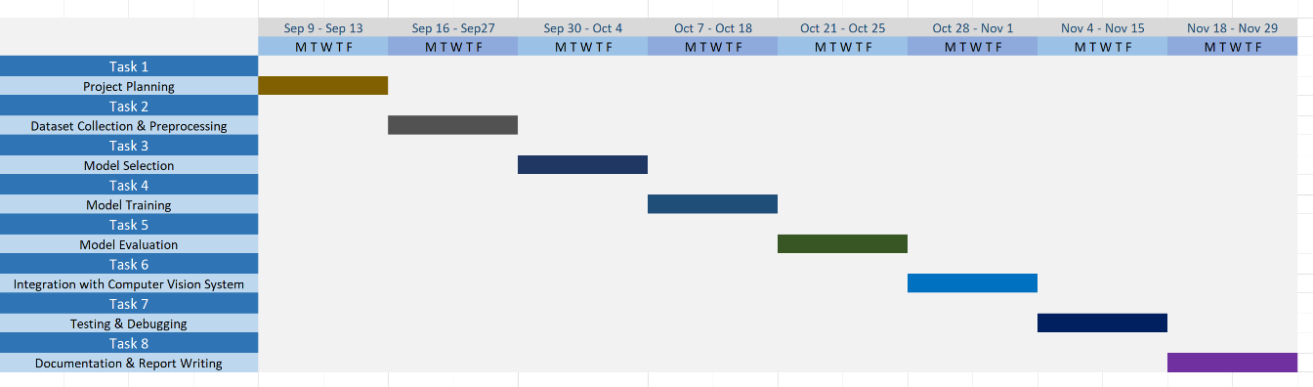

4. Methodology/ Planning of work

A structured approach for developing an acutely insightful project on real-time sign language recognition through computer vision and learning. These essentially involve:

* Collect and preprocess 24 images of alphabetic hand gestures snapped by the camera; these are preprocessed into HSV format where the hand region is masked out and resized to 28x28 pixels in the gray scale.
* Feature Extraction: The above-preprocessed images extract the hand region from the background. Dataset: Store all these preprocessed images as 1x784 matrices.
* The model involves a CNN and is designed to capture learning features from actions then downsampling from features to categorize the actions into letters.
* Training & Testing : At this phase, the current dataset was divided into two halves, 85 % for training, and the rest 15 % for testing. Subsequently, its accuracy on testing was tested after training the provided CNN.
* It is then applied for real-time gesture recognition after training the model. It processes a video frame in real-time and recognizes hand gestures and presents the relevant letters.
* Since the assessment allows account in system accuracy, it can easily withstand any challenge which may emerge due to variable lighting conditions and skin tones. Architecture Diagram (High-level Overview): Captures hand motion with camera Pre-processing Grayscale: Apply the grayscale on the image Isolated hand. Feature Extraction: Extracts the most probably feature of the hand gesture. Uses CNN Classification Using a pre-trained CNN model and classify it. Output: Shows the recognition of the letter on the screen display.

5. Tools/Technology Used:

5.1 Minimum Hardware Requirements

Hardware required for the development of the project.

* **CPU:**
* **RAM:**
* **GPU:**
* **HDD:**
* **Others(if any):**

5.2 Minimum Software Requirements

Software required for the development of the project.

* **OS :**

6. References: [IEEE format]:

J. J. Raval and R. Gajjar, "Real-time Sign Language Recognition using Computer Vision," *2021 3rd International Conference on Signal Processing and Communication (ICPSC)*, Coimbatore, India, 2021, pp. 542-546.